**What is Concurrent React?**

Concurrency – new rendering approach was introduced. Previously, rendering of react components was synchronous, with concurrency we can interrupt rendering (pausing, continuing).  
For example, sooner React will introduce <Offscreen> component (when a user tabs away from a screen and back, React should be able to restore the previous screen in the same state it was in before).

**Automatic Batching**

React will collect all states to change and apply 1 render for all changed states **for Async events too**.

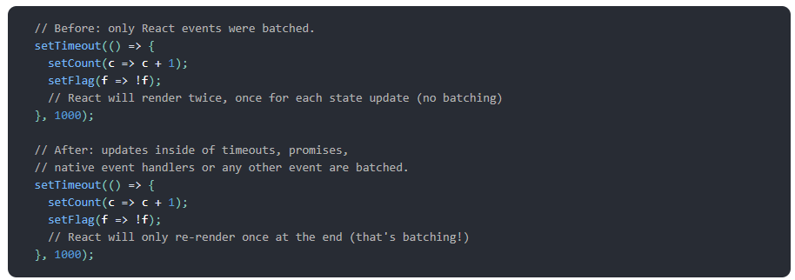

**New Hooks**

useId() – generates new id

useDeferredValue()

useTransition()

